Braking the shackles of ADHD labels

Prof Jannie Ferreira

jannieferreira446@gmail.com

I have the following hypothesis that I wish to share with you: If you are –

* A boy
* Born between September and December [children in South Africa]
* Have cross dominance or left eye dominant

Then you have a 100% chance of being labelled ADHD, ADD or dyslexic.

The whole ADHD debate is something that has been on my mind for some time. I simply cannot accept that so many children are deemed to suffer from this genetic disease. Yes the supporters of this concept call it just that. How is it possible that we as humans seem to be unable to adapt to our environment and why is there such an increase in children with ADHD since the turn of the century. The CDC [Centre for Disease Control] in the USA recently estimated the treatment cost together with the societal and personal costs to be in the order of 31.6 billion US dollars per annum [in the USA]. This would then include:

* Health care for persons with ADHD
* Health care for family members specifically related to the family member’s diagnosis
* Work absence among people with ADHD and family members.

Other than the staggering cost to society the other thing that really fired up my research interest, is my own experience of the impact this label has on both the individual and his/her family. It breaks my heart to see these people – the child with ADHD label with very little self-esteem and the boys almost disconnected and the girls also suffering from anxiety. The parents, mostly moms that need to deal with this, with total despair on their faces.

I admit that because of this I have developed a total adversity to children being labelled ADHD and made it my mission to remove these labels with obvious criticism from several quarters. I believe my persistence is paying off since more and more researchers are now questioning this. Recently I got hold of a statement made by Jerome Kagan. This gentleman was a professor in psychology at Harvard University and a couple of years ago his was rated as one of the most influential psychologists of the 20th century. He ranked higher than Carl Jung [founder of analytical psychology] and Ivan Pavlov [pavlovian reflex]. In an interview with *Spiegel* he stated that “the diagnosis of ADHD is an invention and only benefits the pharmaceutical industry and psychiatrists”. He continues by saying that this inaccurate diagnosis have a devastating effect because the people think there is something fundamentally wrong with them. Needless to say that I whole heartedly support these statements and this brings me back to my initial hypothesis. Taking medication is not going to chance your gender, your date of birth or your dominance. So why do we give medication to these children because they do not suffer from abnormal dopamine metabolism.

Studying the literature confirm that boys are far more prone to be diagnosed with ADHD than girls. I have not encountered a single study linking this to genetics or dopamine metabolism differences. What is true is that boys and girls do differ in the way they deal with what the experience to be stressful situations. Boys fall back on their survival brain that will encourage them to get out of the situation [stop concentrating!] while girls will go to their emotional brain [want to please] and would therefore try harder to cope. Sadly there is a down side to this – I see more young girls being put on antidepressant drugs to deal with their anxiety. Again I went back to the literature and found reports stating that one in 40 children in the USA are taking antidepressant drugs. You can expect to see more of this in our own country unless we prevent it from happening.

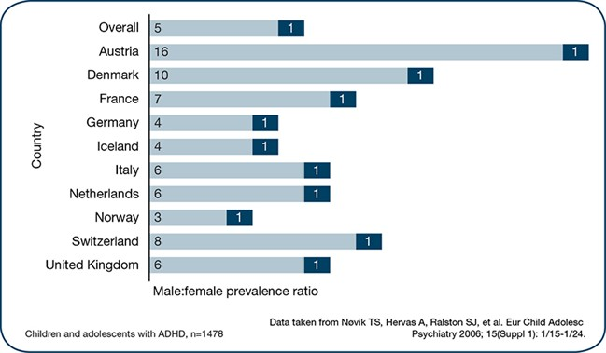

Moving on to the birth date part of my hypothesis. Again I was surprized to find many studies all over the world [USA, Canada, Taiwan, Australia] dealing with this concept and all are in agreement that the younger children in the class have a far better chance of being labelled ADHD. Again there is a growing concern coming from these studies on the criteria used to diagnose children with ADHD and the consensus is that most children are wrongly diagnosed. Some studies also raised the concern that in most cases the teachers were the first people to suggest the presence of ADHD in these children. I have a massive respect for teachers but we will have to educate and assist them in dealing with the whole ADHD matter.

The third part of my hypothesis deals with dominance. Being part of the Mindmoves organisation I don’t have to tell you about the challenges and frustrations resulting from cross dominance. Not surprizing then to find a number of studies reporting on the relation between ADHD symptomatology and cerebral dominance. There are even studies linking eye-dominance to learning disabilities. Again there seems to be a growing consensus that brain dominance cannot cause ADHD but these children may present with ADHD symptoms. A Canadian group did a mega-analysis on the distribution of hand and eye dominance in a number of other studies. They came to the conclusion that one out of 10 people are left hand- and 9 out of 10 people are right hand dominant. Four people were found to be left eye dominant and the other six right eye dominant. This mean that three people are cross dominant. Therefore four out of 10 are left eye dominant and these people will all have a good chance of being labelled ADHD.

I have not found any study that linked gender, birth date and dominance with ADHD and this is therefore a first attempt to do this. The motive should be obvious and from my own data base of more than 1000 children I know that we can reduce the ADHD symptoms dramatically by dealing with the visual frustrations. Combining this with the Mindmoves exercises have helped to remove the ADHD label in many children. It simply means that by far the majority of children walking around with an ADHD label do not deserve this. We should refrain from labelling them and deal with the symptoms for what they are and not put them on medication just to “calm then down”. Being left eye dominant, a male and born in August person myself I am living prove that one can survive all these “drawbacks”.

I wish to request your co-operation in collecting data for this hypothesis. I therefore kindly request you to look at your own data base and please let me know if my hypothesis holds true or not. Would you please also provide me with statistics on girls that are on antidepressants and anxiety medication.

All references used in this article are available from the author on request.